# Module 1 - Day 2

## Lesson 1: Introduction to Web Development: HTML, XML, and Markdown

### Introduction to Hypertext Markup Language (HTML)

* HTML stands for Hypertext Markup Language.
* It is the standard markup language for documents designed to be displayed in a web browser.
* HTML describes the structure of a web page semantically and can include cues for presentation.

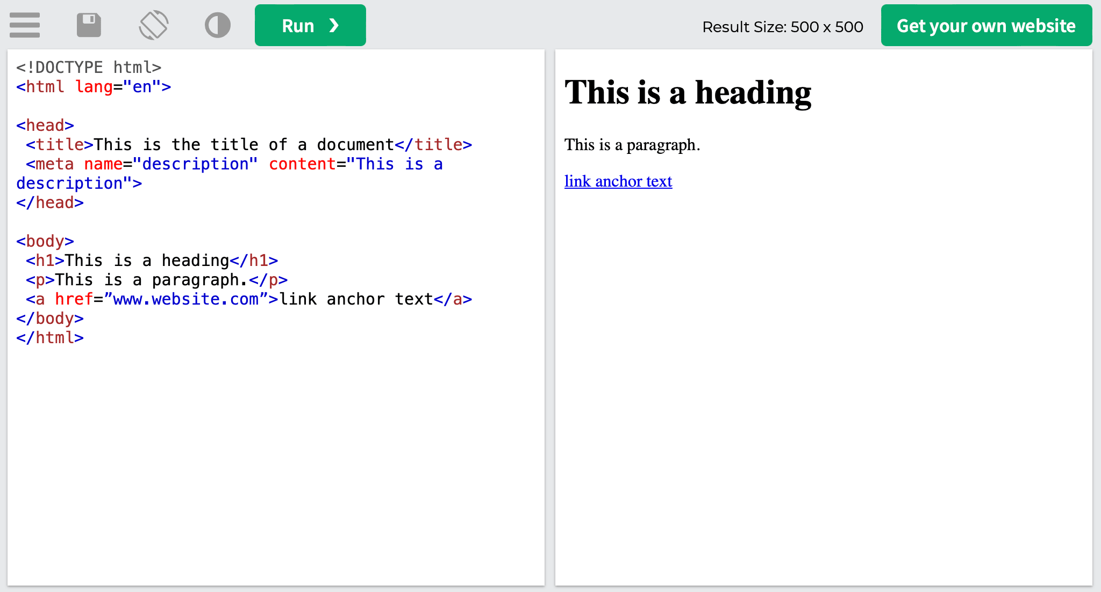

### XML and Markdown

* XML stands for eXtensible Markup Language. It was designed to store and transport data. Unlike HTML, it doesn't do anything on its own - it's simply a way of describing data that allows software to interpret the data accurately.

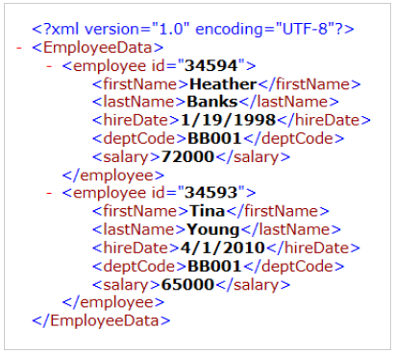

* Markdown is a lightweight markup language for creating formatted text using a plain-text editor. It's often used for writing on the web in a way that's easy to read and write. Unlike HTML and XML, Markdown is less about data structure and more about quickly applying styles (such as italics, bold, and links) to text.

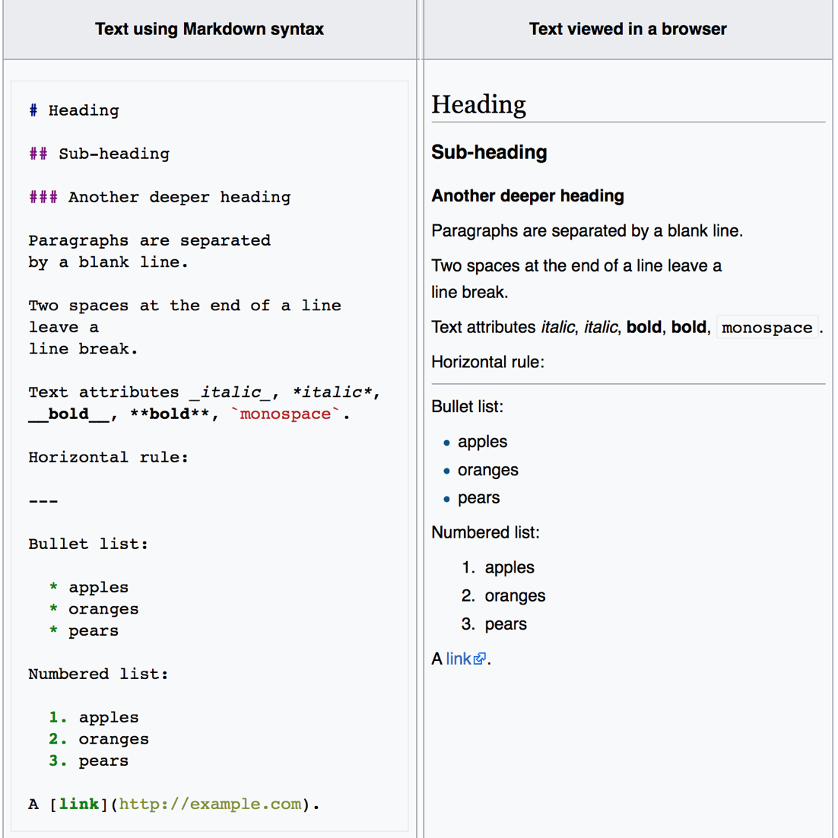

Source: [GitHub and Markdown](https://open-learning-exchange.github.io/#!pages/vi/vi-github-and-markdown.md)

### How does a web browser work?

* A web browser takes the HTML, CSS, and JavaScript of a website and translates it into a visual display.
* It communicates with a server to request the files that make up the web page.
* Once the browser receives the files (HTML, CSS, JS, images, etc.), it interprets them and renders the webpage on your screen.

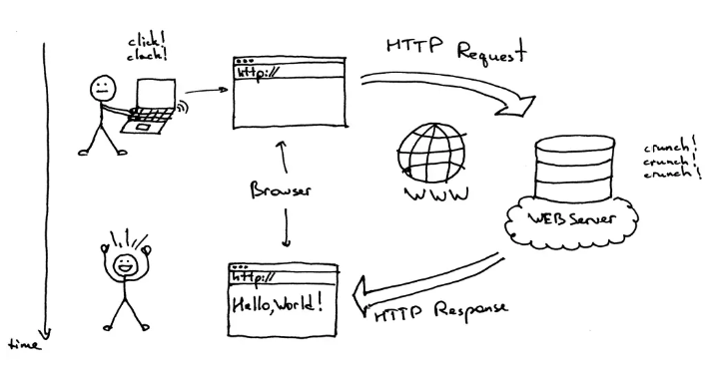

### Common elements of a webpage

* **Headings:** HTML headings are defined with the <h1> to <h6> tags.
* **Paragraphs:** HTML paragraphs are defined with the <p> tag.
* **Images:** HTML images are defined with the <img> tag.
* **Links:** HTML links are defined with the <a> tag.
* **Lists:** HTML lists are defined with the <ul> (unordered/bullet list), <ol> (ordered/numbered list), and <li> (list item) tags.
* **HTML Document Structure:** An HTML document is structured into <!DOCTYPE html>, <html>, <head>, and <body>.

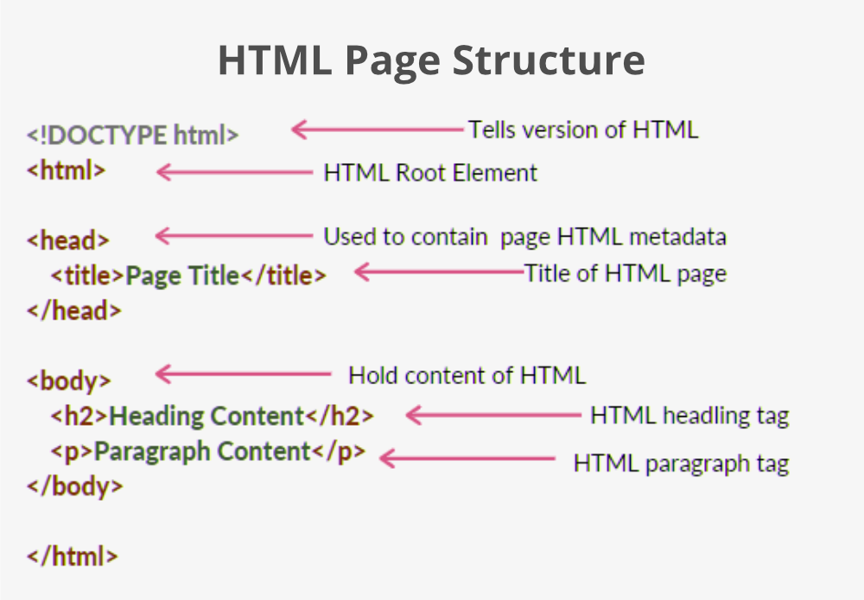

### Basic HTML Syntax

<!DOCTYPE html>

<html>

<head>

<title>Page Title</title>

</head>

<body>

<h1>My First Heading</h1>

<p>My first paragraph.</p>

</body>

</html>

* <!DOCTYPE html>: HTML version
* <html>: HTML document
* <head>: meta-information
* <title>: title bar/tab name
* <body>: body of the document (what you see on the page)
* <h1> to <h6>: headings
* <p>: paragraphs

### Resources

* [Introduction to HTML - Mozilla Developer Network (MDN)](https://developer.mozilla.org/en-US/docs/Learn/HTML/Introduction_to_HTML)
* [Your first HTML - MDN](https://developer.mozilla.org/en-US/docs/Learn/HTML/Introduction_to_HTML/Getting_started)
* [HTML Basics - W3Schools](https://www.w3schools.com/html/html_basic.asp)
* [XML Tutorial - W3Schools](https://www.w3schools.com/xml/)
* [Markdown Guide](https://www.markdownguide.org/)
* [How Browsers Work: Behind the Scenes of Modern Web Browsers - HTML5 Rocks](https://www.html5rocks.com/en/tutorials/internals/howbrowserswork/)
* [Introduction to the DOM - MDN](https://developer.mozilla.org/en-US/docs/Web/API/Document_Object_Model/Introduction)
* [HTML Style Guide](https://www.w3schools.com/html/html5_syntax.asp)

## 

## Lesson 2 - Building Your First HTML Webpage

### Build Your "Hello, World!" Page

1. Review this CodePen to see an example: <https://codepen.io/shafferma08/pen/oNaLdBW>

### More Formatting - Page Background

* You can change the background color of your webpage using the style attribute in the <body> tag.

<body style="background-color:lightblue;">

### Inline Styling

* Inline CSS is used to style individual HTML elements directly in the HTML structure using the style attribute.

<p style="color:red;">This is a red paragraph.</p>

### Hexadecimal Notation

* Hexadecimal (or hex) color codes are a way to specify colors in CSS. They start with a hashtag (#) followed by six digits which represent red, green, and blue (RGB) in hexadecimal format.

<p style="color:#FF0000;">This is a red paragraph.</p>

### Adding Title and Head

* The <title> tag is nested within the <head> tag. The content inside the <title> tag will appear as the title of the webpage on the browser tab.

<head>

<title>My First Page</title>

</head>

### Adding an Image as Background (Inline HTML)

* Inline CSS can be used to set an image as a background.

<body style="background-image: url('image.jpg');">

Replace 'image.jpg' with the URL or the path of your image.

### HTML Entity Symbols

* HTML entities are used to display reserved characters in HTML. For example, to display less than (<) or greater than (>), you can use &lt; or &gt; respectively.
* Other common HTML entities include &amp; for ampersand (&), &quot; for quotation mark (").

### Common CSS properties that can be used in inline styling

1. **color:** This property sets the color of the text. The color can be named (like "red"), hex (like "#ff0000"), rgb (like "rgb(255, 0, 0)"), or rgba (like "rgba(255, 0, 0, 0.5)").

<p style="color: red;">This is a red paragraph.</p>

1. **background-color:** This sets the background color of an element.

<div style="background-color: yellow;">This is a div with a yellow background.</div>

1. **font-size:** This sets the size of the font.

<p style="font-size: 20px;">This is a paragraph with 20px font size.</p>

1. **font-family:** This sets the font of the text. The value can be a specific font name ("Arial", "Times New Roman", etc.) or a generic font family (serif, sans-serif, monospace, cursive, fantasy).

<p style="font-family: Arial;">This paragraph uses the Arial font.</p>

1. **text-align:** This aligns the text. Possible values are "left", "right", "center", and "justify".

<p style="text-align: center;">This is a centered paragraph.</p>

1. **border:** This sets the border around an element. It's a shorthand property for border-width, border-style, and border-color.

<div style="border: 2px solid black;">This is a div with a black border.</div>

1. **text-shadow:** This applies a shadow to the text. It takes three length values (for horizontal shadow, vertical shadow, and blur radius) and a color value.

<p style="text-shadow: 2px 2px 4px blue;">This is a paragraph with a blue text shadow.</p>

1. **background-image:** This sets a background image for an element. It takes a URL to the image file.

<div style="background-image: url('https://example.com/image.jpg');">This is a div with a background image.</div>

1. **background-repeat:** This sets whether/how a background image will be repeated. Can be "repeat", "repeat-x", "repeat-y", or "no-repeat".

<div style="background-image: url('https://example.com/image.jpg'); background-repeat: no-repeat;">This is a div with a non-repeating background image.</div>

You can combine multiple properties in a single style attribute, just make sure to separate them with semicolons.

### Finding Image URLs Online

* Images on the internet have their own URL (Uniform Resource Locator), a specific web address that points directly to the image file. This URL can be used to embed or reference the image from your HTML code.
* You can find the URL of an image online by following these steps:
  1. Navigate to the web page where your desired image is.
  2. Right-click on the image.
  3. Select "Copy Image Address" or "Copy Image Location" - the exact wording will depend on your web browser. This action copies the direct URL of the image to your clipboard.
* Remember to only use images that are freely available and respect copyright laws. Some websites, like Unsplash or Pexels, offer high-quality images that are free to use. Wikimedia Commons is another source for freely usable media files.
* Once you have the image URL, you can use it as a background image like this:

Background image example:

<body style="background-image: url('<https://upload.wikimedia.org/wikipedia/commons/e/e4/Crimson_sunset.jpg>');">

Image example:

<!-- Replace "image_url_here" with the actual URL of the image you want to display -->

<img src="https://www.example.com/image_url_here.jpg" alt="Example Image">

Replace the URL within the single quotes (' ') with the URL of your chosen image.

Note: Ensure that the image you choose has a high enough resolution to look good as a background image, and that it's not copyrighted or requires specific attribution if used. Always respect the licenses of the images you use in your projects.

### Resources

1. [HTML Tutorial: HTML & CSS for Beginners - Codecademy](https://www.codecademy.com/learn/learn-html)
2. [HTML head - MDN](https://developer.mozilla.org/en-US/docs/Web/HTML/Element/head)
3. [HTML title - MDN](https://developer.mozilla.org/en-US/docs/Web/HTML/Element/title)
4. [HTML Text Formatting - W3Schools](https://www.w3schools.com/html/html_formatting.asp)
5. [HTML Styles - W3Schools](https://www.w3schools.com/html/html_styles.asp)
6. [CSS Hexadecimal Colors - W3Schools](https://www.w3schools.com/css/css_colors_hex.asp)
7. [HTML Images - W3Schools](https://www.w3schools.com/html/html_images.asp)
8. [HTML Entities - W3Schools](https://www.w3schools.com/html/html_entities.asp)
9. [Upload a File in Codio](https://docs.codio.com/common/develop/ide/workspace/upload-download-files.html)

## 

## Lesson 3: Tools of the Trade - Text Editors, IDEs

### Tools of the Trade: Text Editors, IDEs, and Other Development Tools

* Text editors, IDEs, and other development tools are essential to web development. These tools help you write, manage, and debug your code effectively.
* Text editors, like Sublime Text or Atom, offer a wide range of features like syntax highlighting, auto-indentation, and support for many programming languages.
* Integrated Development Environments (IDEs), like Visual Studio Code or JetBrains WebStorm, are advanced tools that combine several functionalities including a text editor, built-in terminal, debugger, and version control integration. They also offer advanced features like IntelliSense (contextual code suggestions) and code refactoring.

### CodePen: Online Code Editor and Social Development Environment

* CodePen is an online platform where developers can write code, create, and share their work. It provides an instant preview of your code's output, making it a great tool for learning and demonstrating web development concepts.
* To use CodePen:
  + Navigate to [CodePen](https://codepen.io/)
  + Sign up for a free account.
  + Click on the 'New Pen' button to create a new project.
  + In the HTML, CSS, and JS sections, write your code. You will see the result of your code live in the preview section. (We are currently focusing on HTML only)
  + Save your projects (Pens) and share them with others or keep them for future reference.

### Resources

* [Visual Studio Code for Beginners](https://code.visualstudio.com/docs/introvideos/basics)

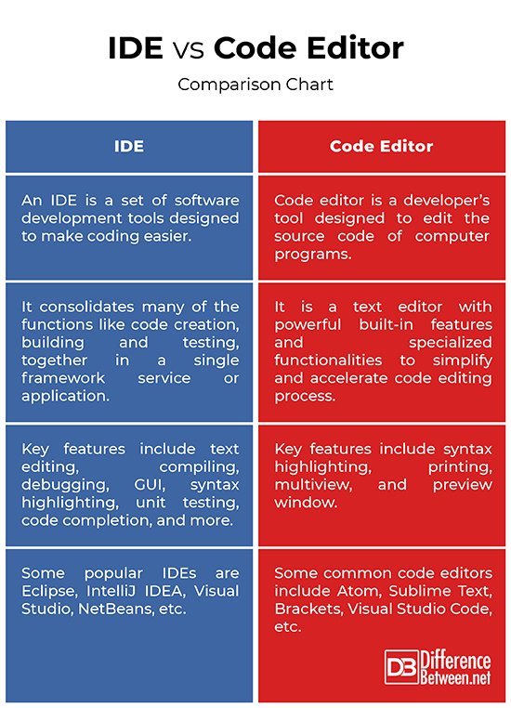

Source: [Difference Between IDE and Code Editor](http://www.differencebetween.net/technology/difference-between-ide-and-code-editor/)

# Module 1 - Day 3

## CodePen Links

* [Module 1 Collection](https://codepen.io/collection/gYjVGw)
* [HTML Sandbox](https://codepen.io/shafferma08/pen/WNaxJrL)
* [Hello World](https://codepen.io/shafferma08/pen/oNaLdBW) (Day 2, Lesson 3 submission)
* [Favorite Artist](https://codepen.io/shafferma08/pen/ExdyRKb) (Day 3, Lesson 1, Exercise 1 submission)
* [Hometown](https://codepen.io/shafferma08/pen/GRYqGwg) (Day 3, Lesson 1, Exercise 2 submission)
* [Hosting Images on Google Drive](https://codepen.io/shafferma08/pen/GRYqxqq)
* [Paul Graham Website](https://codepen.io/shafferma08/pen/wvYWXPK) (Day 3, Lesson 2 submission)